Municipality, Date
Easy-to-read
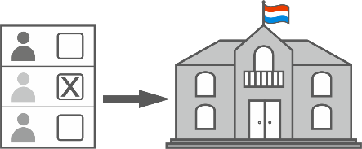
Dear fellow citizen,
Do you want to make a difference in your municipality?
The municipal council represents the citizens.
Do you want to decide,
who will be on your municipal council?
Then vote in the municipal elections.
Another word is: communal elections.
The municipal elections are on Sunday, June 11, 2023.
Only then you will have a say in what happens in your municipality in the future.
For example: Where will new houses and roads be built?
All people can participate and have a say:
- People who have 18 years or more
- People who have always lived in the municipality
- People who are new in the municipality
- Luxembourgers and Non-Luxembourgers.
The new election law says:
Non-Luxembourgers are also allowed to vote in Luxembourg
in the municipal elections.
read more

But you can only vote
if you are registered on the electoral list in your municipality.
You are a Luxembourger?
Then you are automatically on the electoral list.
And you have to vote.
You are a Non-Luxembourger?
Then register on the electoral list in your municipality.
You can do this until Monday, April 17, 2023 at 5 pm.
You can do it as soon as you live in Luxembourg.
You have 3 possibilities:
1. You go to the website www.guichet.lu.
2. You scan this QR code with your cell phone:

3. Or you go to the citizen's office of your municipality.
And you fill in a form there.
In Luxembourgish we also say "Bierger-Center" or "Bierger-Amt".
It is the office for the people in the municipality.
For example, you go there to register in the municipality.
Or if you have questions about the municipality.
The opening hours are on the website of the municipality.

read more

Are you already on the electoral list?
Then share your experience with other Non-Luxembourgers.
Explain to them why it is important to participate in the elections.
When you vote in municipal elections, you participate:
- for yourself
- for your family and friends
- so that all citizens in your community live well together.
We all decide about the future of our municipality.
That is why your crosses on the ballot paper are important.
Your vote counts!
Come to the municipal elections on Sunday, June 11, 2023.
Before the elections you will receive a letter with more info:
For example: time, place, how to vote....

Visit www.icanvote.lu for more info:
- about the elections
- how to sign up for an electoral list.
You can scan the QR code with your cell phone.
The website is in difficult language.
The Municipal Council (Gemengerot)

Easy-to-read language by Klaro and Atelier isie of the APEMH
© European Easy-to-Read Logo: Inclusion Europe.
More information at https://www.inclusion-europe.eu/easy-to-read/

